Protect your base from evil Thing

1. Project Overview
This project is a Tower Defend and third-person action game built entirely with Python and Pygame and some numpy and numba for matrix computing to create a custom software 3D renderer. The player explores a 3D world from a third-person perspective, defeats enemies with a weapon, and places defensive towers on a grid-based map to protect their base combining the strategic depth of tower defence with the immersion of a 3D shooter.

2. Project Review
Existing project reviewed: Plants vs. Zombies (PopCap Games, 2009)

Plants vs. Zombies is a lane-based tower defence game in which the player places plant units on a grid to stop waves of zombies from reaching the house. Key mechanics include resource (sun) collection, grid-based placement, and wave progression.

Planned improvements in this project:
- Upgrade from a 2D top-down view to a full 3D third-person perspective using a custom software renderer.
- Introduce an Inventory system ( Wrench) so the player can do tower management in real time.
- Add an in-world Shop building that the player must physically walk to in order to purchase towers and upgrades.
- Implement statistical data recording (position, score, accuracy, enemies defeated) for post-game analysis.

3. Programming Development

3.1 Game Concept
The game takes place on a fixed map consisting of a 6×5 placement grid in the centre, a Base building on the right, an Enemy Spawn zone on the left, and a Shop above the grid. Enemies spawn in waves and follow a path toward the base. The player must protect the base by:
- Placing towers on grid cells using the Wrench item.
- Earning currency from defeated enemies and spending it at the Shop.

The game ends when the base HP reaches zero (lose) or all waves are cleared (win). Between waves, the player enters a Prep Phase to place additional towers and restock.

3.2 Object-Oriented Programming Implementation
The following classes will be implemented:

Class | Key Attributes | Key Methods / Role
Player | position, velocity_y, angle_y, hp | update(), draw(), handle movement, gravity, animation
Enemy | position, hp, speed, waypoints, reward | update() follows path, take_damage(), die() drops currency
Tower | position (grid cell), damage, range, fire_rate | update() auto-aims nearest enemy, shoot() spawns projectile
Inventory | slots {1: Wrench}, current | handle_event() KEYDOWN swap, update(), draw_hud() slot bar
Map / Grid | cells[row][col], GRID_ROWS, GRID_COLS | world_to_cell(), cell_to_world(), place(), is_empty()
GameState | currency, base_hp, wave, phase | on_enemy_die(), spend(), start_wave(), check_win_lose()
Wave | wave_number, enemy_queue, spawn_timer | update() timed spawn, is_complete()
HUD | font, fps_timer | draw() overlays FPS, position, currency, base HP, wave counter

3.3 Algorithms Involved
- Painter's Algorithm polygons sorted by depth (far to near) each frame for correct 3D rendering without a Z-buffer.
- Waypoint Pathfinding enemies follow a fixed list of 3D waypoints; each frame the enemy steers toward the next waypoint and advances when within threshold distance.
- AABB Collision Detection axis-aligned bounding box checks for player vs. walls and player vs. ground, with penetration resolution.
- Wave Scheduler a timer-based algorithm counts down between spawns and between waves, escalating enemy count and speed each round.
- Grid Mapping world-space coordinates are translated to discrete grid cells (row, col) and back, enabling O(1) tower placement and occupancy checks.

4. Statistical Data (Prop Stats)

4.1 Data Features

Feature Name | Why it is good to have this data? What can it be used for? | How will you obtain 100 values of this feature data? | Which variable (and which class will you collect this from)? | How will you display this feature data (via summarization statistics or via graph)?
1. Enemy Lifespan (Time-to-Kill) | To analyze game balance and tower effectiveness by tracking how long enemies manage to survive before being destroyed.. | By recording the time each enemy spawns and the time it dies. With multiple waves, you will easily log over 100 enemy lifespans | A calculated survival_time variable (death time minus spawn time) from the Enemy class. | Via graph: Histogram (showing the distribution of how long enemies stay alive).
2. Enemies Defeated | To track time-to-kill, tower/player attribution, and analyze player efficiency across different waves. | By generating a per-enemy record every time an enemy is killed. The continuous spawning of enemies across multiple waves will quickly exceed 100 rows. | The reward variable and die() method from the Enemy class. | Via graph: Bar graph (showing the total number of enemies defeated per wave).
3. Currency Earned & Spent | To log each transaction with its source (kill reward vs. wave bonus) and track player spending habits. | By logging every transaction that occurs when currency is earned from kills or spent at the Shop. | The currency variable via the spend() and on_enemy_die() methods from the GameState class. | Via Summarization statistics (Mean, median, and standard deviation for currency efficiency ).
4. Base HP Over Time | To track the difficulty curve and evaluate player performance across sessions. | By sampling the data every wave-end across multiple gameplay sessions to accumulate over 100 rows. | The base_hp variable from the GameState class. | Via graph: Line graph (showing Base HP over waves to visualize difficulty ).
5. Tower Purchase Tracking | To analyze player preferences and game balance by identifying which tower types are purchased most frequently. | By logging an entry every time the player purchases a tower from the Shop. Across multiple waves and sessions, this will easily exceed 100 purchases. | The item purchased data during the spend() method in the GameState class and the Tower type variable. | Via graph: Pie graph (showing the proportion of each tower type purchased by the player).

Feature Name | Graph objective | Graph type | X-axis | Y-axis
1. Base HP Over Time | To visualize the game's difficulty curve and track how the base's health depletes over the course of the game. | Line Graph | Wave Number (or Time in seconds) | Base HP (Health Points)
2. Enemies Defeated | To compare the number of enemies successfully defeated in each wave. | Bar Graph | Wave Number | Number of Enemies Defeated
3. Enemy Lifespan (Time-to-Kill) | To show the distribution of how long enemies survive on the map before being eliminated. | Histogram | Lifespan Duration (Seconds) | Frequency (Number of Enemies)

4.3 Hand draw graph
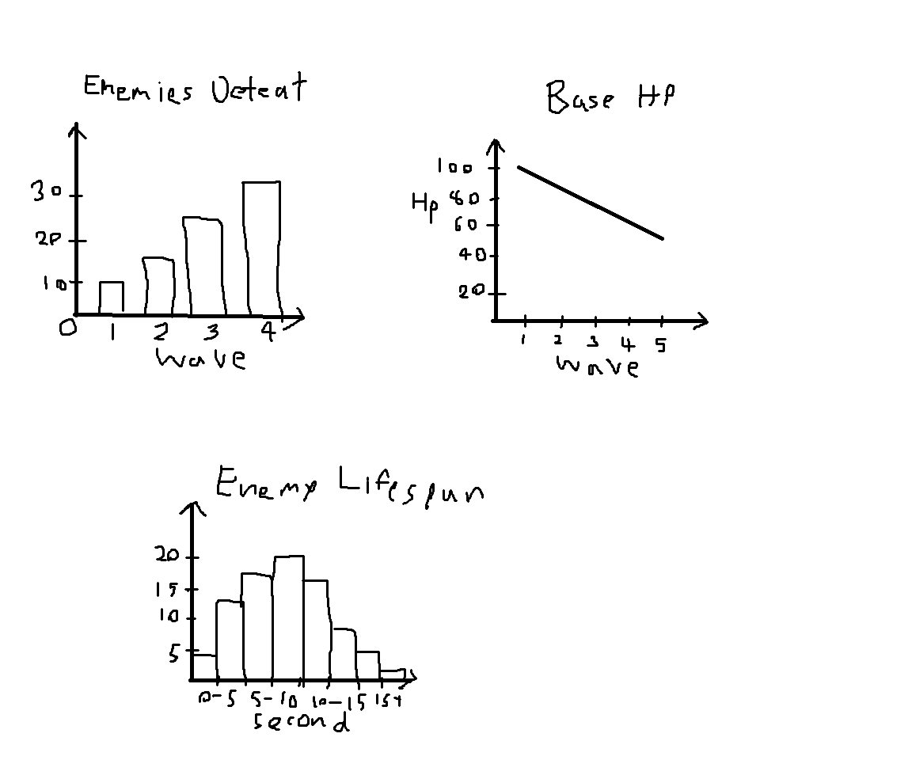

5. Project Planning Timeline
Week | Task
1 | Proposal submission / Project initiation — finalize game design & file structure
2 | Implement core engine: flat ground, camera, player movement
3 | Build Map system: Grid, Base, Shop, Enemy Spawn zone
4 | Implement Enemy, Wave, Tower placement via Wrench
5 | Game State system: currency, base HP, win/lose condition
6 | UI/HUD polish, Inventory system, statistical data recording (CSV)
7 | Submission week (Draft) — testing, bug fixing, data analysis report

6. Document Version
Version: 1.2
Date: 12 March 2025
Editor: Pensiri Yakongko

# delete weapon feature because it may cause lag
# sorry for being late i already fix it but it didnt update and i didnt see that when i send

